

SIMATS ENGINEERING

Saveetha Institute of Medical and Technical Sciences
Chennai- 602105

Student Name: K. V. Charan Reg. No.:192424190
Course Code: DSA0216 Slot: B
Course Name: Computer Vision with OpenCV for Modern AI
Course Faculty: Dr. S. Senthilvadivu & Dr.T. Kumaragurubaran
Project Title: Face Recognition-Based Attendance System Using Camera And Python To Improve
Accuracy And Efficiency
Module Photographs:
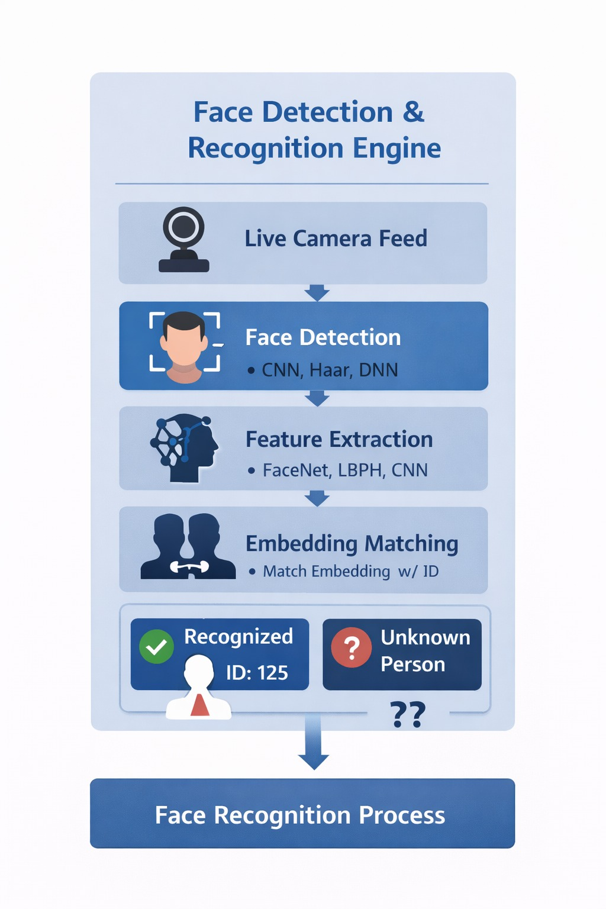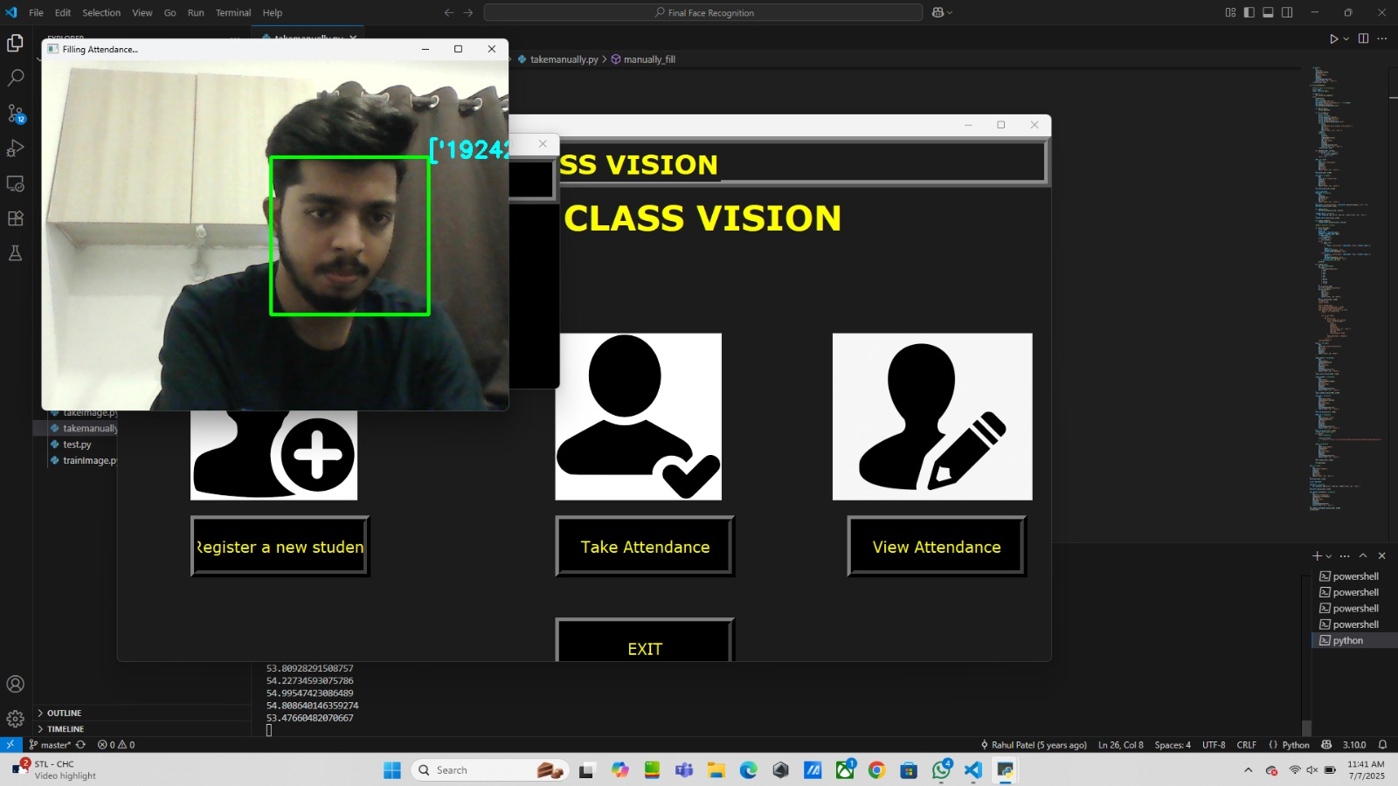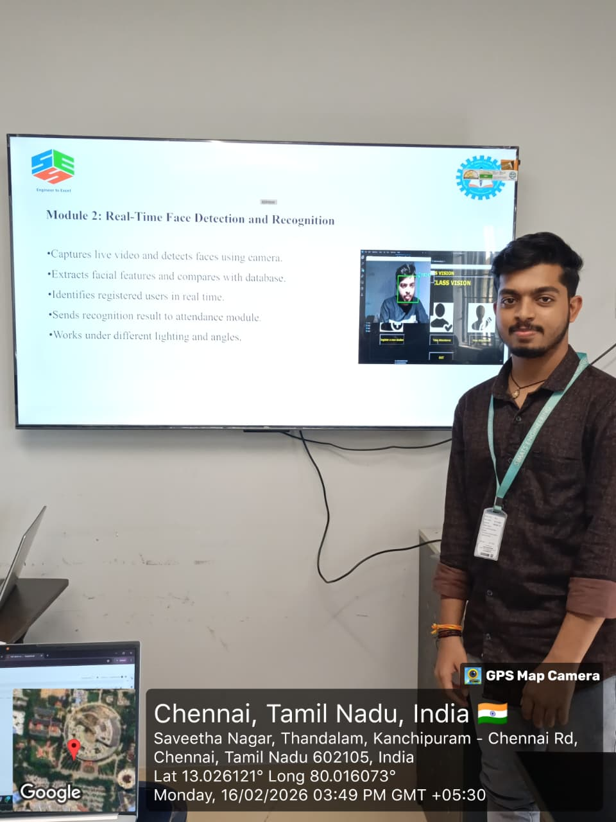
Project Description:
The Face Recognition-Based Attendance System Using Camera and Python to Improve Accuracy and Efficiency relies on intelligent recognition to identify individuals accurately and efficiently. In this system, Module 2 – Face Detection & Recognition Engine serves as the core processing unit that detects and recognizes faces in real time. The module processes live video input, extracts facial features using techniques such as LBPH, and compares them with trained data to determine identity. My contribution included designing the detection and recognition workflow, training and optimizing the model, tuning matching thresholds to reduce false results, and enhancing real-time performance using OpenCV. These improvements ensured fast processing, stable performance, and reliable identification under various conditions. I also implemented confidence score evaluation to improve matching accuracy. Additionally, I reduced false positives by fine-tuning recognition parameters. The module was tested under different lighting conditions to ensure robustness and consistency. Continuous performance monitoring was performed to maintain system accuracy.

Student Signature Guide Signature

